# Level 1 of 32

### Type Selector

## Select elements by their type

### A

Selects all elements of type **A**. Type refers to the type of tag, so div, p and ul are all different element types.

#### Examples

**div** selects all div elements.

**p** selects all p elements.

# 

**Answer : Plate**

# Level 2 of 32

### Type Selector

## Select elements by their type

### A

Selects all elements of type **A**. Type refers to the type of tag, so div, p and ul are all different element types.

#### Examples

**div** selects all div elements.

**p** selects all p elements.

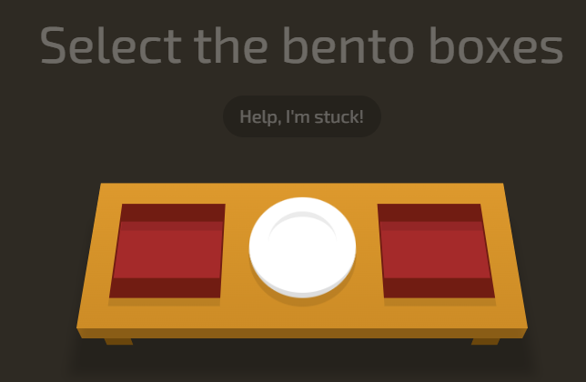

**Answer : Bento**

# Level 3 of 32

### ID Selector

## Select elements with an ID

### #id

Selects the element with a specific **id**. You can also combine the ID selector with the type selector.

#### Examples

**#cool** selects any element with **id="cool"**

**ul#long** selects ul id="long"

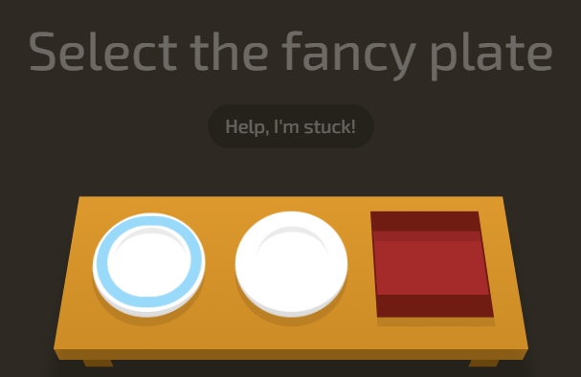

**Answer : #fancy**

# Level 4 of 32

**Descendant Selector**

Select an element inside another element

A  B

Selects all B inside of A. B is called a descendant because it is inside of another element.

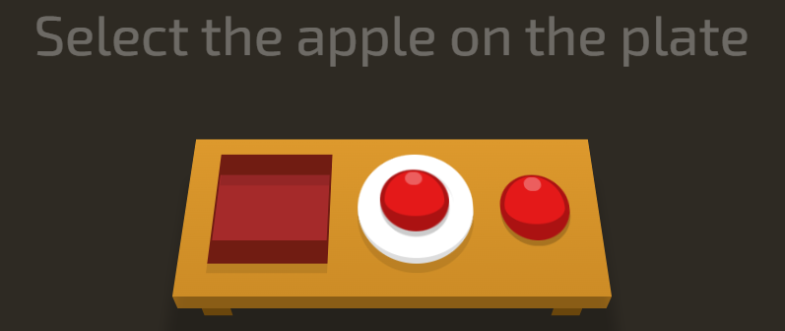

**Answer : Plate apple**

# Level 5 of 32

## Combine the Descendant & ID Selectors

### #id  A

You can combine any selector with the descendent selector.

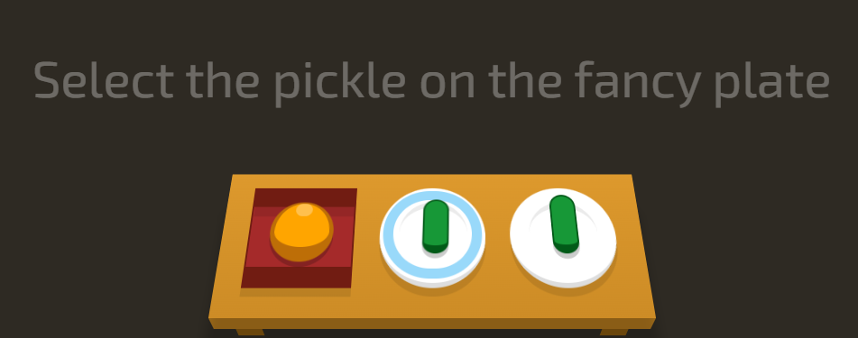

**Answer : #fancy pickle**

# Level 6 of 32

### Class Selector

## Select elements by their class

### .classname

The class selector selects all elements with that class attribute. Elements can only have one ID, but many classes.

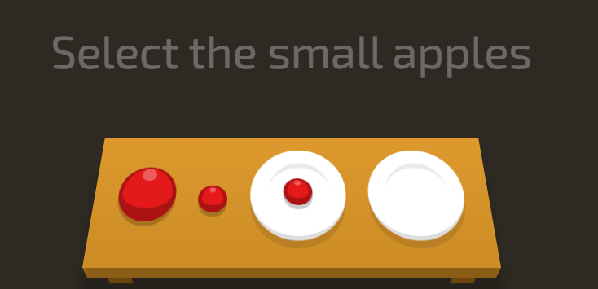

**Answer : .small**

# Level 7 of 32

## Combine the Class Selector

### A.className

You can combine the class selector with other selectors, like the type selector.

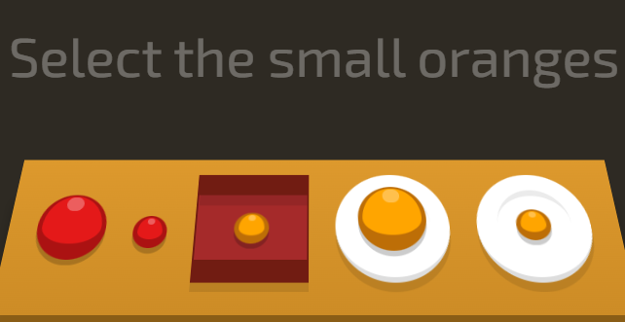

**Answer : Orange.small**

# Level 8 of 32

## You can do it...

### Put your back into it!

Combine what you learned in the last few levels to solve this one!



**Answer : bento orange.small**

# Level 9 of 32

### Comma Combinator

## Combine, selectors, with... commas!

### A, B

Thanks to Shatner technology, this selects all **A** and **B** elements. You can combine any selectors this way, and you can specify more than two.

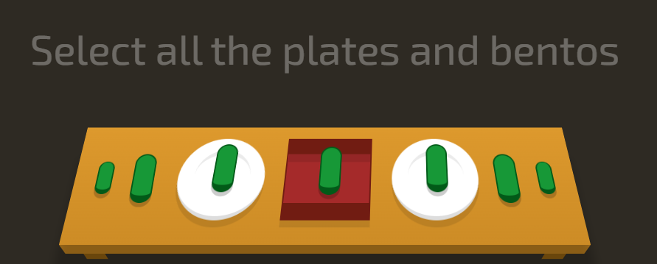

**Answer : bento,plate**

# Level 10 of 32

### The Universal Selector

## You can select everything!

### *

You can select all elements with the universal selector!

#### Examples

**p \*** selects any element inside all p elements.

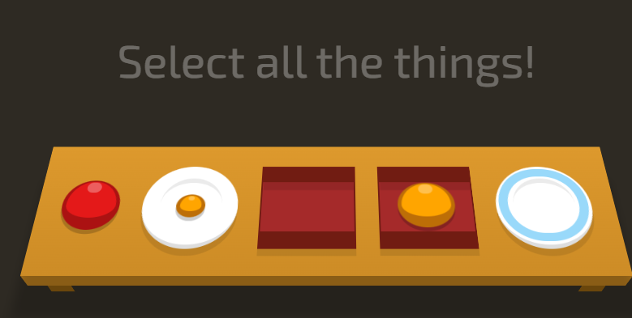

**Answer : \***

# Level 11 of 32

## Combine the Universal Selector

### A  *

This selects all elements inside of **A**.

#### Examples

**p \*** selects every element inside all p elements.

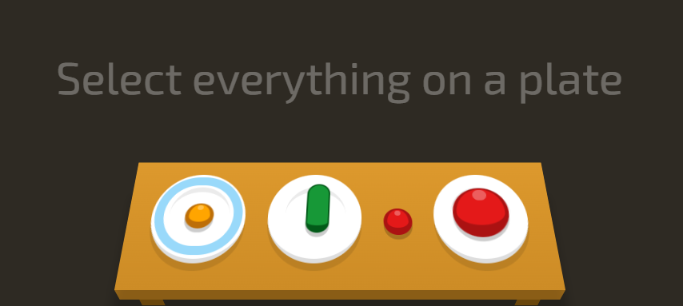

**Answer : plate \***

# Level 12 of 32

### Adjacent Sibling Selector

## Select an element that directly follows another element

### A + B

This selects all **B** elements that directly follow **A**. Elements that follow one another are called siblings. They're on the same level, or depth.  
  
In the HTML markup for this level, elements that have the same indentation are siblings.

#### Examples

**p + .intro** selects every element with **class="intro"** that directly follows a p

**div + a** selects every a element that directly follows a div

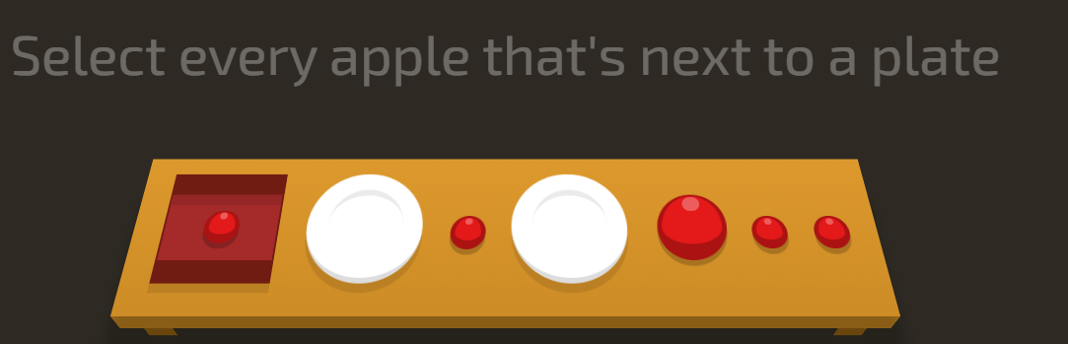

**Answer : plate + apple**

# Level 13 of 32

### General Sibling Selector

## Select elements that follows another element

### A ~ B

You can select all siblings of an element that follow it. This is like the Adjacent Selector (A + B) except it gets all of the following elements instead of one.

#### Examples

**A ~ B** selects all **B** that follow a **A**

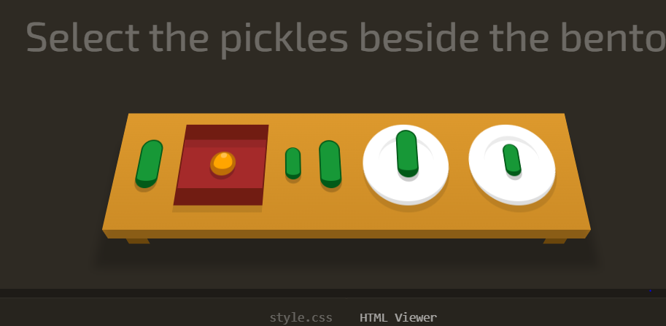

**Answer : pickle ~ pickle**

# Level 14 of 32

### Child Selector

## Select direct children of an element

### A > B

You can select elements that are direct children of other elements. A child element is any element that is nested directly in another element.  
  
Elements that are nested deeper than that are called descendant elements.

#### Examples

**A > B** selects all **B** that are a direct children **A**

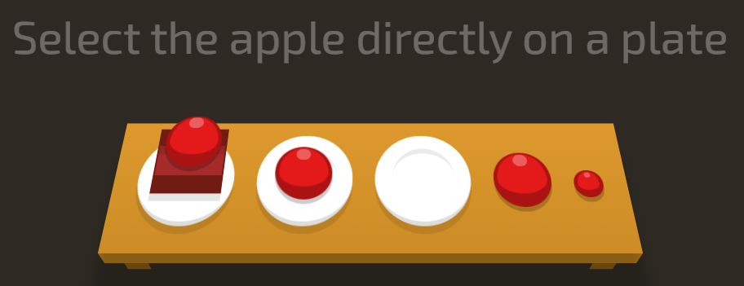

**Answer : plate > apple**

# Level 15 of 32

### First Child Pseudo-selector

## Select a first child element inside of another element

### :first-child

You can select the first child element. A child element is any element that is directly nested in another element. You can combine this pseudo-selector with other selectors.

#### Examples

**:first-child** selects all first child elements.

**p:first-child** selects all first child p elements.

**div p:first-child** selects all first child p elements that are in a div.

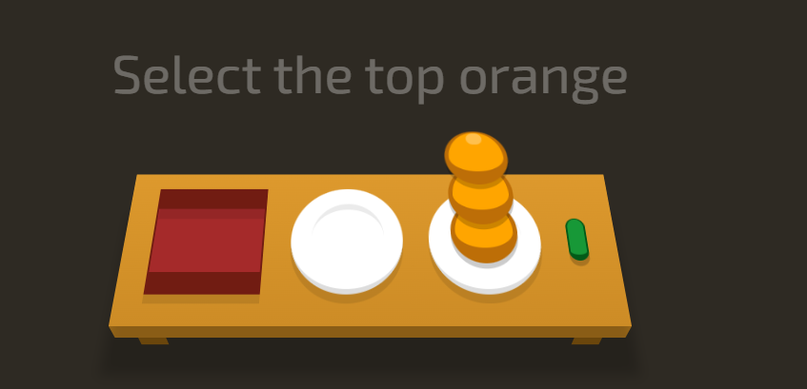

**Answer : orange:first-child**

# Level 16 of 32

### Only Child Pseudo-selector

## Select an element that are the only element inside of another one.

### :only-child

You can select any element that is the only element inside of another one.

#### Examples

**span:only-child** selects the span elements that are the only child of some other element.

**ul li:only-child** selects the only li element that are in a ul.



**Answer : plate apple, plate pickle**

**plate apple:only-child, plate pickle:only-child**

# Level 17 of 32

### Last Child Pseudo-selector

## Select the last element inside of another element

### :last-child

You can use this selector to select an element that is the last child element inside of another element.  
  
Pro Tip → In cases where there is only one element, that element counts as the first-child, only-child and last-child!

#### Examples

**:last-child** selects all last-child elements.

**span:last-child** selects all last-child span elements.

**ul li:last-child** selects the last li elements inside of any ul.

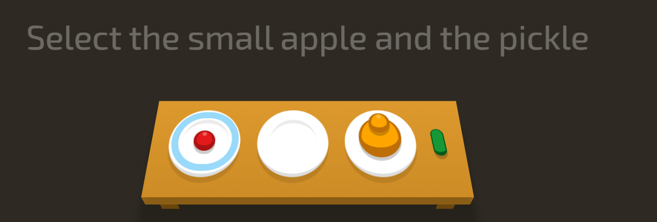

**Answer : apple:last-child, pickle:last-child**

# Level 18 of 32

### Nth Child Pseudo-selector

## Select an element by its order in another element

### :nth-child(A)

Selects the **nth** (Ex: 1st, 3rd, 12th etc.) child element in another element.

#### Examples

**:nth-child(8)** selects every element that is the 8th child of another element.

**div p:nth-child(2)** selects the second **p** in every **div**

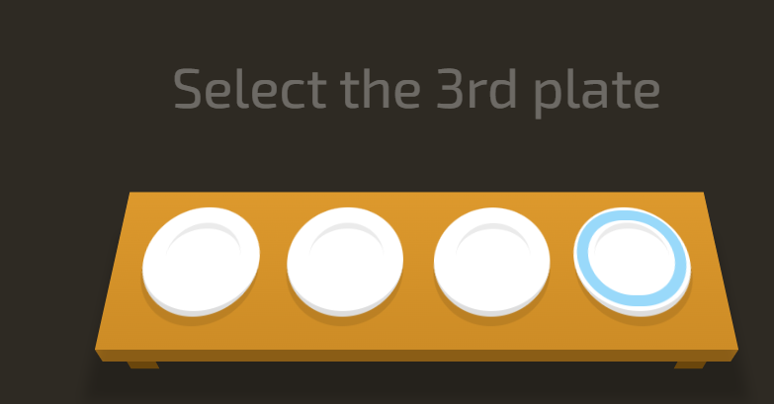

**Answer : plate:nth-child(3)**

# Level 19 of 32

### Nth Last Child Selector

## Select an element by its order in another element, counting from the back

### :nth-last-child(A)

Selects the children from the bottom of the parent. This is like nth-child, but counting from the back!

#### Examples

**:nth-last-child(2)** selects all second-to-last child elements.

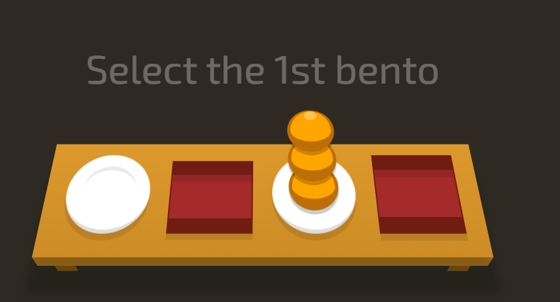

**Answer : bento:nth-last-child(3)**

# Level 20 of 32

### First of Type Selector

## Select the first element of a specific type

### :first-of-type

Selects the first element of that type within another element.

#### Examples

**span:first-of-type** selects the first span in any element.

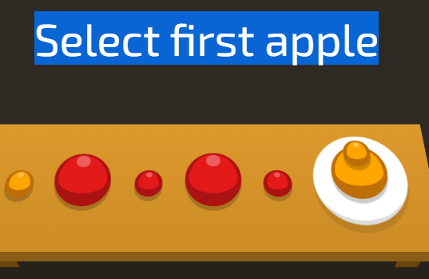

**Answer : apple:first-of-type**

# Level 21 of 32

### Nth of Type Selector

### :nth-of-type(A)

Selects a specific element based on its type and order in another element - or even or odd instances of that element.

#### Examples

**div:nth-of-type(2)** selects the second instance of a div.

**.example:nth-of-type(odd)** selects all odd instances of a the example class.

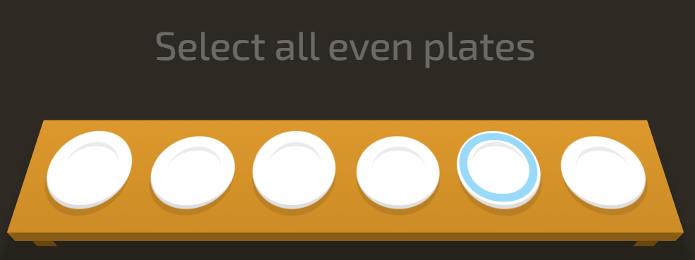

**Answer : plate:nth-of-type(even)**

# Level 22 of 32

### Nth-of-type Selector with Formula

### :nth-of-type(An+B)

The nth-of-type formula selects every nth element, starting the count at a specific instance of that element.

#### Examples

**span:nth-of-type(6n+2)** selects every 6th instance of a span, starting from (and including) the second instance.

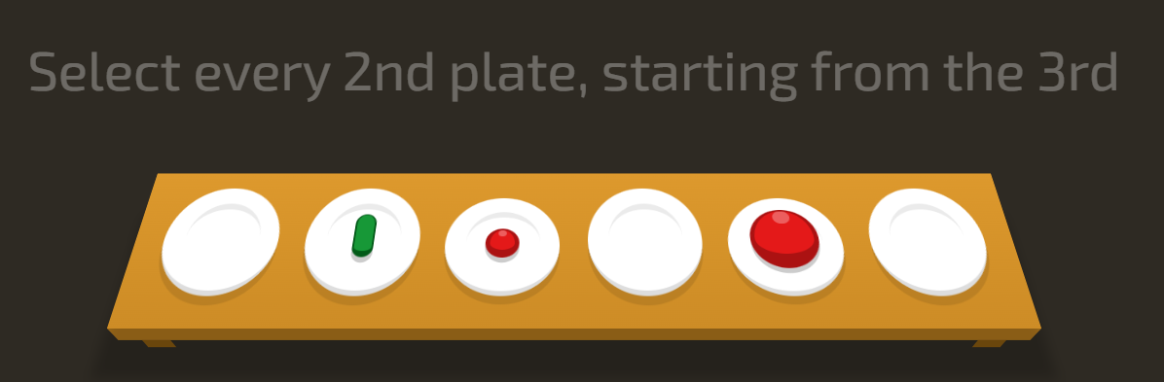

**Answer : plate:nth-of-type(2n+3)**

# Level 23 of 32

### Only of Type Selector

## Select elements that are the only ones of their type within of their parent element

### :only-of-type

Selects the only element of its type within another element.

#### Examples

**p span:only-of-type** selects a span within any p if it is the only span in there.

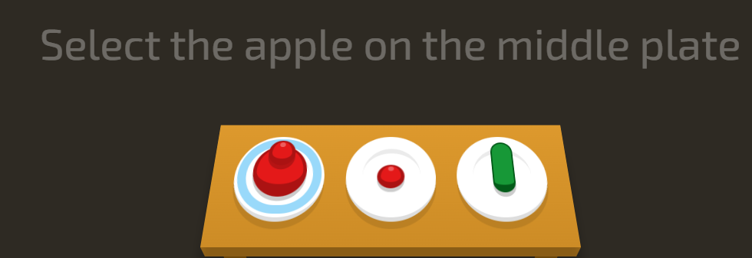

**Answer : plate apple:only-of-type**

# Level 24 of 32

### Last of Type Selector

## Select the last element of a specific type

### :last-of-type

Selects each last element of that type within another element. Remember type refers the kind of tag, so p and span are different types.  
  
I wonder if this is how the last dinosaur was selected before it went extinct.

#### Examples

**div:last-of-type** selects the last div in every element.

**p span:last-of-type** selects the last span in every p.

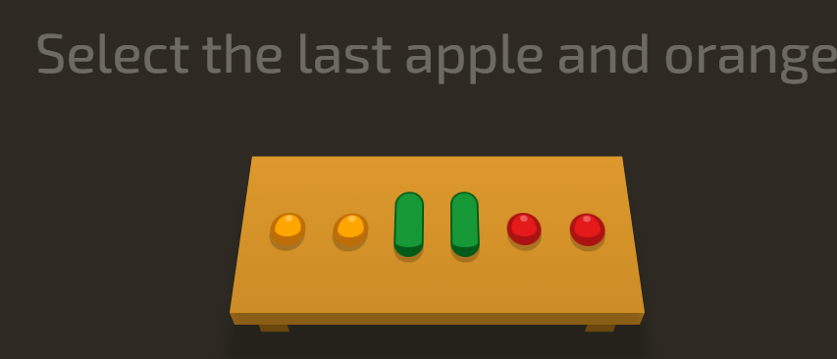

**Answer : orange:last-of-type, apple:last-of-type**

# Level 25 of 32

### Empty Selector

## Select elements that don't have children

### :empty

Selects elements that don't have any other elements inside of them.

#### Examples

**div:empty** selects all empty div elements.

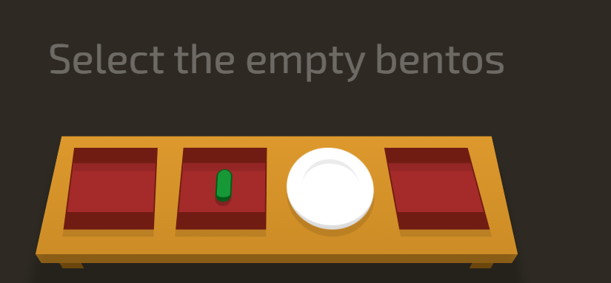

**Answer : bento:empty**

# Level 26 of 32

### Negation Pseudo-class

## Select all elements that don't match the negation selector

### :not(X)

You can use this to select all elements that do not match selector **"X"**.

#### Examples

**:not(#fancy)** selects all elements that do not have **id="fancy"**.

**div:not(:first-child)** selects every div that is not a first child.

**:not(.big, .medium)** selects all elements that do not have **class="big"** or **class="medium"**.

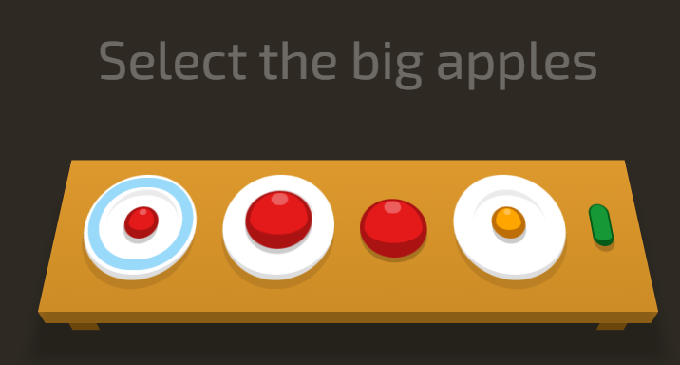

**Answer : apple:not(.small)**

# Level 27 of 32

### Attribute Selector

## Select all elements that have a specific attribute

### [attribute]

Attributes appear inside the opening tag of an element, like this: span attribute="value". An attribute does not always have a value, it can be blank!

#### Examples

**a[href]** selects all a elements that have a **href="anything"** attribute.

**[type]** selects all elements that have a **type="anything"**. attribute

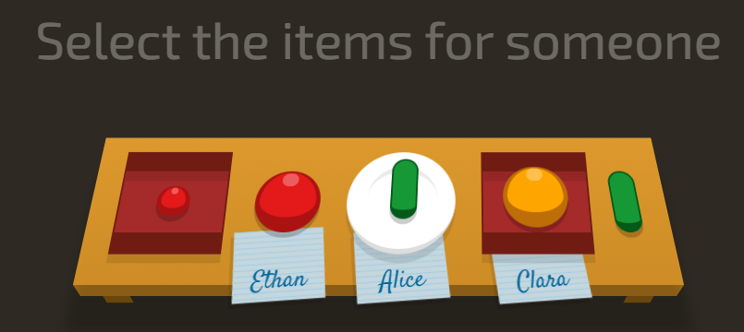

**Answer : *[for]**

# Level 28 of 32

### Attribute Selector

## Select all elements that have a specific attribute

### A[attribute]

Combine the attribute selector with another selector (like the tag name selector) by adding it to the end.

#### Examples

**[value]** selects all elements that have a **value="anything"** attribute.

**a[href]** selects all a elements that have a **href="anything"** attribute.

**input[disabled]** selects all input elements with the **disabled** attribute

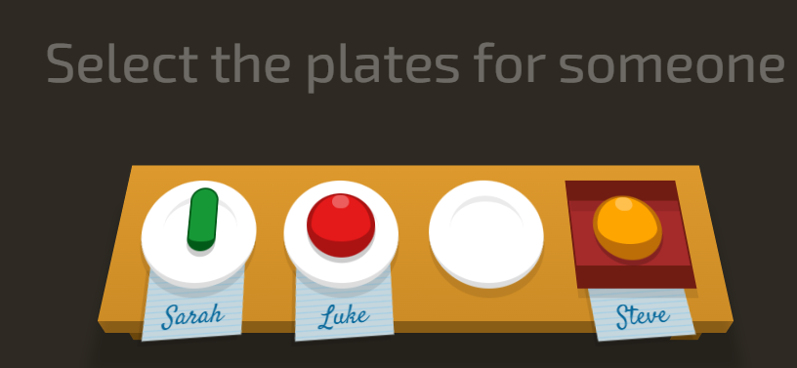

**Answer : plate[for]**

# Level 29 of 32

### Attribute Value Selector

## Select all elements that have a specific attribute value

### [attribute="value"]

Attribute selectors are case sensitive, each character must match exactly.

#### Examples

**input[type="checkbox"]** selects all checkbox input elements.

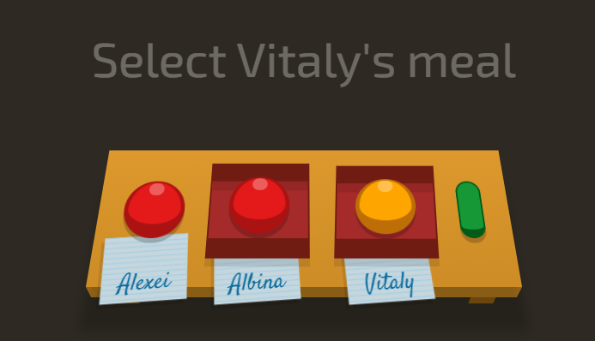

**Answer : bento[for="Vitaly"]**

# Level 30 of 32

### Attribute Starts With Selector

## Select all elements with an attribute value that starts with specific characters

### [attribute^="value"]

#### Examples

**.toy[category^="Swim"]** selects elements with class **toy** and either **category="Swimwear** or **category="Swimming"**.

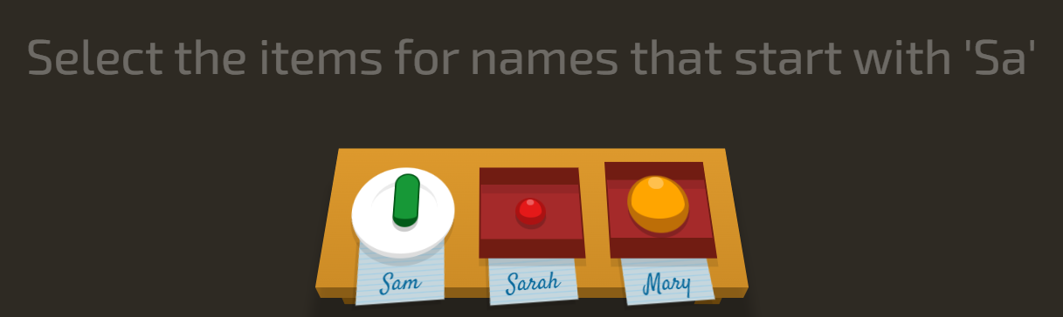

**Answer : plate[for],bento[for="Sarah"]**

# Level 31 of 32

### Attribute Ends With Selector

## Select all elements with an attribute value that ends with specific characters

### [attribute$="value"]

#### Examples

**img[src$=".jpg"]** selects all images display a **.jpg** image.

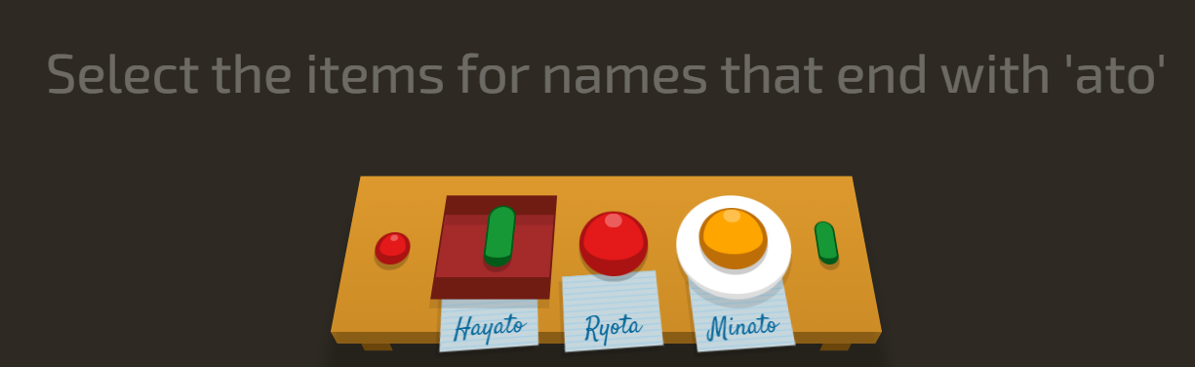

**Answer : [for$="ato"]**

# Level 32 of 32

### Attribute Wildcard Selector

## Select all elements with an attribute value that contains specific characters anywhere

### [attribute*="value"]

A useful selector if you can identify a common pattern in things like **class**, **href** or **src** attributes.

#### Examples

**img[src*="/thumbnails/"]** selects all image elements that show images from the "thumbnails" folder.

**[class*="heading"]** selects all elements with "heading" in their class, like **class="main-heading"** and **class="sub-heading"**

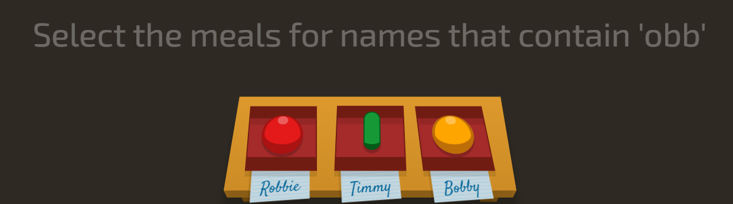

**Answer : [for*="bb"]**

